**Practical No:07**

**Layouts: Write programs for the following layouts:**

1. **Border Layout**

**Code:**

import javax.swing.*;

import java.awt.*;

import java.awt.event.*;

import java.util.*;

class demo extends JFrame implements ActionListener

{

JPanel p1,p2;

JButton b1,b2;

JLabel l;

Int c=0;

String[] img={"na3.png","na2.png","na4.png"};

demo()

{

setSize(300,200);

p1=new JPanel();

p2= new JPanel();

//p1.setPreferredSize(new Dimension(350, 190));

l=new JLabel(new ImageIcon(img[c]));

p1.add(l);

b1=new JButton("Back");

b2=new JButton("Next");

p2.add(b1);

p2.add(b2);

setVisible(true);

setLayout(new BorderLayout());

add(p1,BorderLayout.CENTER);

add(p2,BorderLayout.SOUTH);

setDefaultCloseOperation(JFrame.EXIT_ON_CLOSE);

b1.addActionListener(this);

b2.addActionListener(this);

}

public void actionPerformed(ActionEvent e)

{

if(e.getSource()==b2)

{

c=(c+1)%img.length;

l.setIcon(new ImageIcon(img[c]));

}

else if(e.getSource()==b1)

{

c=(c-1+img.length)%img.length;

l.setIcon(new ImageIcon(img[c]));

}

}

public static void main(String[] args)

{

new demo();

}

}

**Output:**

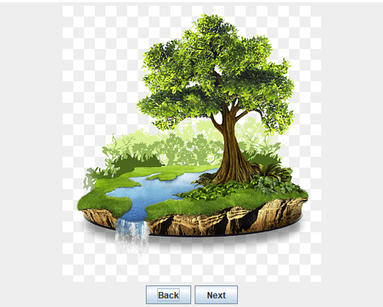

**After clicking next**

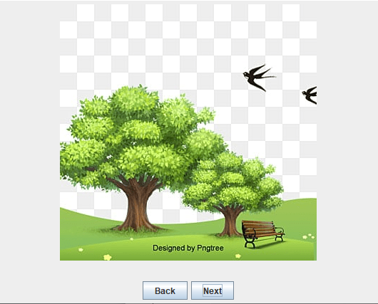

**After clicking back**

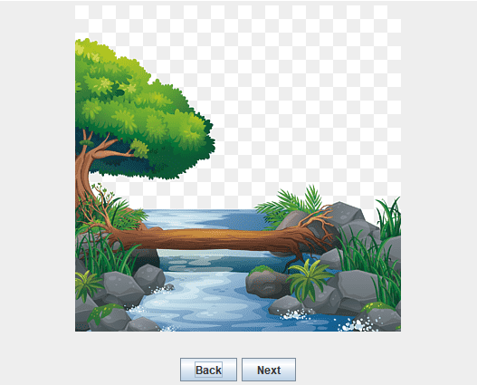

1. **Flow Layout**

**Code:**

import javax.swing.*;

import java.awt.*;

import java.*;

import java.awt.event.*;

class square extends JFrame implements ActionListener

{

JLabel l1,l2;

JButton b;

JTextField t;

square()

{

new JFrame("Calculator");

setSize(400,200);

setVisible(true);

setDefaultCloseOperation(JFrame.EXIT_ON_CLOSE);

setLayout(new FlowLayout());

l1=new JLabel("enter number");

add(l1);

t=new JTextField(10);

add(t);

b=new JButton("Square");

add(b);

b.addActionListener(this);

l2=new JLabel();

add(l2);

}

public void actionPerformed(ActionEvent e)

{

String a=t.getText();

int b=Integer.parseInt(a);

int c=b*b;

l2.setText(Integer.toString(c));

}

public static void main(String args[])

{

new square();

}

}

**Output:**

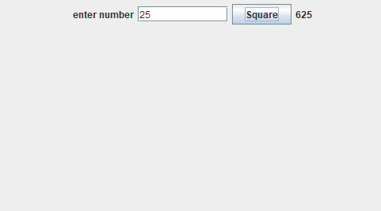

1. **Grid Layout**

**Code:**

import java.awt.*;

import javax.swing.*;

class demo extends JFrame {

JPanel p;

JTextField t;

JButton b1, b2, b3, b4, b5, b6, b7, b8, b9, b10, b11, b12, b13, b14, b15, b16;

demo(){

setSize(300, 400);

t = new JTextField(10);

p = new JPanel();

p.setLayout(new GridLayout(4, 4, 3, 3));

b1 = new JButton("1");

b2 = new JButton("2");

b3 = new JButton("3");

b4 = new JButton("4");

b5 = new JButton("5");

b6 = new JButton("6");

b7 = new JButton("7");

b8 = new JButton("8");

b9 = new JButton("9");

b10 = new JButton("0");

b11 = new JButton("+");

b12 = new JButton("-");

b13 = new JButton("/");

b14 = new JButton("*");

b15 = new JButton("=");

b16 = new JButton("C");

p.add(b1);

p.add(b2);

p.add(b3);

p.add(b4);

p.add(b5);

p.add(b6);

p.add(b7);

p.add(b8);

p.add(b9);

p.add(b10);

p.add(b11);

p.add(b12);

p.add(b13);

p.add(b14);

p.add(b15);

p.add(b16);

setVisible(true);

setDefaultCloseOperation(JFrame.EXIT_ON_CLOSE);

setLayout(new BorderLayout());

add(p, BorderLayout.CENTER);

add(t, BorderLayout.NORTH);

t.setPreferredSize(new Dimension(250, 40));

setResizable(false);

}

public static void main(String[] args) {

new demo();

}

}

**Output:**

